Related DAX Function

Consider 2 tables Employee and Dept. Dept is the Parent table and Employee is the child table.

Dept table has columns Deptno, DName and Location.

Employee table has columns Empno, Ename, Salary and Deptno.

Suppose we want to add the DName column in the Employee table then we can use the DAX function known as Related.

**RELATED can access the one-side from the many-side because there is only one rows exists in the related table and if no matching row exists, RELATED will return BLANK.**

That means Related function can be used in the child table to get the corresponding value *(which will be only one value)* from its parent table.

Create a **New Column** in **Employee** table, i.e. the child table:

**DName = Related(Dept[DName])**

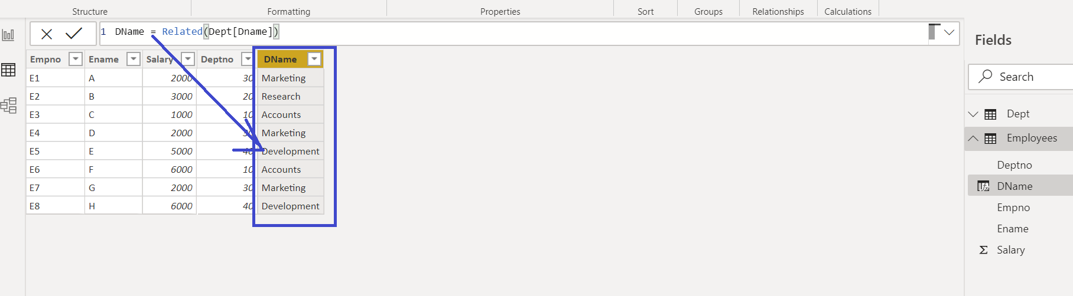

Note 🡪 The DAX function **Related** will only work if there is **relation between those 2 tables**. If the relation is broken or not established then these functions will throw error.

Caution: Related DAX function cannot be used in the parent table when the corresponding child table has many rows.

For example, we want to create a new column in Dept table which will show the number of rows for each deptno from the Employee table.

**Number of Employees = COUNTROWS(Related(Emp[Deptno]))**

In this scenario we have to use **RelatedTable** DAX function.

RelatedTable function can be used in the parent table to get multiple rows information of its child table.

**RELATEDTABLE(Table)** follows a relationship in either direction (many-to-one or one-to-many) and returns a table containing all the rows that are related to the current row from the specified table. This is very useful when you want to find all the transactions associated with a particular row of a related table.

Rectify the new column of **Dept** table

**Number of Employees = COUNTROWS(RELATEDTABLE(Employees))**

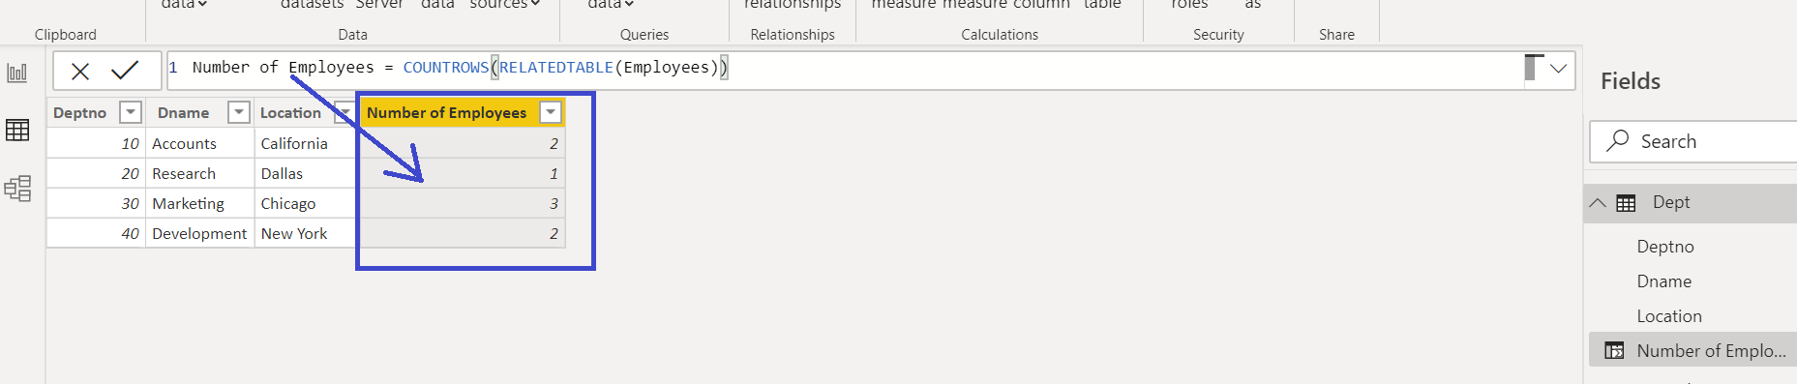

**RELATEDTABLE is a function that returns a table and not a scalar value**. This means that this function cannot be used by itself to define a calculated column or a measure. Instead this function can only be used to provide an intermediate result that is in turn an argument to another function, such an aggregation function.